**The Problem of Supporting High Flexibility of State Management of a Multicultural Region’s Economy and Its Solutions**

**Elena V. Kletskova, Olga V. Titova and Viktoria V. Vorobyeva[1]**

**Abstract**

Purpose: The purpose of the chapter it to develop the algorithms of flexible state management of changes in the economy of a multicultural region and to approbate them by the example of top-3 multicultural regions of modern Russia.

Design/methodology/approach: The authors distinguish two specific directions of state management of economy that require high flexibility in a multicultural region: management of migration flows and management of foreign economic activities. High flexibility of state management within these directions should be ensured through systemic monitoring of the tendencies of development of these directions and implementation of the differentiated measures depending on the determined tendencies and current opportunities and needs of a multicultural region: the corresponding measures of stimulation of the existing tendencies or measures of their restraint.

Findings: It is shown that the modern multicultural regions need flexible state management of their economy in two directions: migration flows and foreign economic activities. The problem of supporting high flexibility of state management of economy of multicultural regions consists in underdevelopment of the scientific and methodological provision of this management depending on the context and the current needs and capabilities of the region.

Originality/value: A perspective method of solving the determined problem is usage of the developed and presented algorithms of flexible state management of migration flows and foreign economic activities in a multicultural region. The compiled algorithms reflect the conditions at which stimulation or restraint of certain economic activities in a multicultural region should be conducted and offer the framework measures of state management.

**Key words** flexibility of state management, regional economy, multicultural region, modern Russia.

**JEL Code** R01, F22, F63, J15, J61, O15, R11, R23, R58, Z13, Z18.

**1 Introduction**

Economy of a multicultural region is susceptible to constant changes. Some changes have the stabilizing influence on the economy of a multicultural region and stimulate its growth and development. Other changes have the destabilizing and destructive influence on the economy of a multicultural region, slowing down its development and increasing the probability of its crisis. That’s why supporting high flexibility of state management of a multicultural region’s economy is very important for the modern science and practice.

Complexity of solving this problem is caused by the fact that is should be solved with “soft” measures – recommendations, not requirements. This is due to the fact that the same changes – depending on the context (current tendencies and needs) – could have positive or negative influence on the region’s economy. That’s why the practice of monocultural regions that is connected to determining the negative changes and prohibiting than and determining the positive changes and stimulating them, as well as determining the limited list of contradictory changes and their flexible regulation, cannot be applied to multicultural regions.

Prohibiting the negative changes at present (e.g., the measures of limitation of foreign investments) could reduce the region’s competitiveness (attractiveness) among multicultural regions (potential territories for placing investments). That’s why when the region feels a need for foreign investments, the possibilities of their attraction will be reduced even if the stimulating measures are introduced. Thus, there’s a need for restraint and strategic orientation during state management of a multicultural region’s economy.

**2 Materials and method**

The necessity for manifesting flexibility during state management of the region’s economy as a socio-economic system of the meso-level, at which changes are more frequent and vivid than at the macro-level, is emphasized in the works [Bezrukova](https://proxylibrary.hse.ru:2073/authid/detail.uri?origin=resultslist&authorId=55928786800&zone=) et al. (2017), [Rocha](https://proxylibrary.hse.ru:2073/authid/detail.uri?origin=resultslist&authorId=35107885700&zone=) and [Abreu](https://proxylibrary.hse.ru:2073/authid/detail.uri?origin=resultslist&authorId=24390508600&zone=) (2018), [Frolov](http://proxylibrary.hse.ru:2178/DaisyOneClickSearch.do?product=WOS&search_mode=DaisyOneClickSearch&colName=WOS&SID=D4wcR7RtBoC5epnnrv3&author_name=Frolov,%20Daniil%20P.&dais_id=2950502&excludeEventConfig=ExcludeIfFromFullRecPage) et al. (2017), [Hilmer Pedersen](https://proxylibrary.hse.ru:2073/authid/detail.uri?origin=resultslist&authorId=57203219732&zone=) and [Johannsen](https://proxylibrary.hse.ru:2073/authid/detail.uri?origin=resultslist&authorId=7004068970&zone=) (2018), [Hu](https://proxylibrary.hse.ru:2073/authid/detail.uri?origin=resultslist&authorId=55265125700&zone=) et al. (2018), [Oliveira](https://proxylibrary.hse.ru:2073/authid/detail.uri?origin=resultslist&authorId=56100165200&zone=) (2017), Popkova (2013), [Popkova](https://proxylibrary.hse.ru:2073/authid/detail.uri?origin=resultslist&authorId=55671568200&zone=) et al. (2017), Sergi et al. (2012), Sergi et al. (2019), Shakhovskaya et al. (2018), Simonova et al. (2017), and Vanchukhina et al. (2019).

At the same time, despite the high level of elaboration of the problem at the theoretical level, it is not sufficiently studied at the empirical level – in particular, the practical solutions that allow ensuring high flexibility of state management of region’s economy are very rare in the existing scientific works and thus require further development, in view of the specifics of multicultural regions.

Two specific directions of state management of economy that require high flexibility in a multicultural region are distinguished:

* management of migration flows;
* management of foreign economic activities.

High flexibility of state management within these directions is to be ensured by systemic monitoring of the tendencies of development of these directions and by implementing the differentiated measures depending on the determined tendencies and current opportunities and needs of a multicultural region: the corresponding measures of stimulation of the existing tendencies or measures of their restraint.

**3 Results**

The following algorithm of flexible state management of migration flows in a multicultural region is offered (Figure 1).

coefficient of tension in the labor market<1

annual growth rate of load on able-bodied population>1

in other cases

Is there a need for migrants?

Monitoring of the number and structure of population (in dynamics) and the labor market in the region

There’s a need for labor migrants

There’s a need for labor migrants

There’s no need and/or the region is overpopulated

Stimulation of employment

Stimulation of self-employment

Canceling of the measures for support for migrants

What is the coefficient of migration growth?

annual growth rate ≥1

annual growth rate <1

Prevention of violations of law

What is the coefficient of migration growth?

annual growth rate ≥1

annual growth rate<1

Additional support for migrants

Figure 1. Algorithm of flexible state management of migration flows in a multicultural region.

Source: developed and compiled by the authors.

As is seen in Figure 1, the initial point of the developed algorithm is monitoring of the number and structure of population (in dynamics) and the labor market in the region. As a result of this monitoring, the multicultural region’s need for migrants is determined. If the annual growth rate of the load on able-bodied population (number of disabled residents of the region per 1,000 able-bodied residents) exceeds 1,000 (i.e., the load grew over the recent year), there is a need for labor migrants. In this case, stimulation of employment through mediation of the state (e.g., in the form of the Chamber of trade and commerce of the region) between job applicants and employers is expedient.

If the coefficient of tension in the labor market (number of job applicants per 1 vacant job) is below 1 (deficit of employees), there’s a need for migrants (not necessarily labor migrants). In this case, it is offered to stimulate self-employment by allocating regional grants for creation and development of companies. Then, if the annual growth rate of the coefficient of migration growth per 10,000 people is below 1 (increase of the incoming flow of migrants in the region is not achieved), it is necessary to additionally support the migrants – e.g., with social benefits, subsidies for rent and purchase of accommodation, etc.

If the need for migrants is absent and/or region is overpopulated, it is necessary to cancel the measures of support for migrants, in order to limit the inflow of migrants into the region and to save the assets of the regional state budget. Then, if the annual growth rate of the coefficient of migration growth per 10,000 people exceeds or equals 1 (inflow of migrants into the region continues), it is necessary to adopt the measures of prevention of violations of law, which growth is explained by increase of unemployment in the region and reduction of living standards, as well as growth of the share of population with the income below the subsistence level. Then, return to the beginning of the algorithm takes place (the algorithm is cyclic).

The approbation of the developed algorithm by the example of top-3 multicultural regions of Russia in 2018 is performed based on the statistics that are shown in Figure 1.

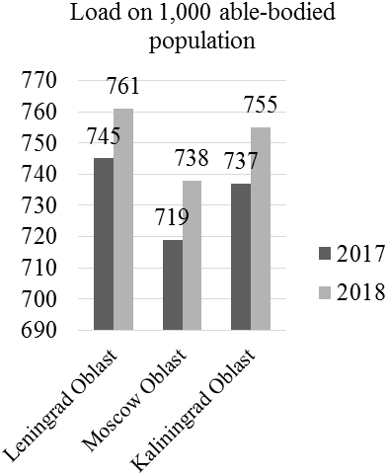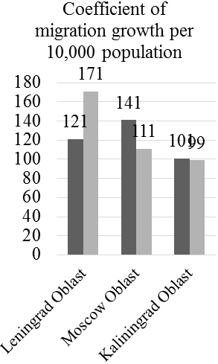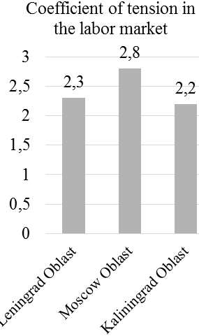

Figure 2. Results of monitoring of the number and structure of population (in dynamics) and the labor market in top-3 multicultural regions of Russia

in 2017-2018.

Source: compiled by the authors based on Federal State Statistics Service (2019).

According to Figure 2, the annual growth rate of the load on able-bodied population in Leningrad Oblast constitutes 1.02 (761/745), in Moscow Oblast – 1.03 (738/737), and in Kaliningrad Oblast – 1.02 (755/737). That’s why it is recommended to stimulate the population’s employment in all regions. The coefficient of tension in the labor market in all regions exceeds 1, constituting 2.3 in Leningrad Oblast, 2.8 in Moscow Oblast, and 2.2 in Kaliningrad Oblast. The annual growth rate of the coefficient of migration growth per 10,000 people in Leningrad Oblast constitutes 1.41 (171/121), in Moscow Oblast – 0.79 (111/141), and in Kaliningrad Oblast – 0.98 (101/99). That’s why there’s a need for additional support for migrants in Moscow and Kaliningrad Oblasts.

The following algorithm of flexible state management foreign economic activities in a multicultural region is offered (Figure 3).

What is the growth rate of the number of companies and their turnover?

low

Stimulation of innovations

positive (export exceeds import)

negative or zero (import equals or exceeds export)

What is the foreign trade balance?

Monitoring of foreign economic activities and commodity markets (in dynamics) in the region

What is the region’s competitiveness?

What is the growth rate of the number of companies and their turnover?

high

Stimulation of export

<1

Stimulation of import substitution

≥1

Limitation of import

<1

≥1

Figure 3. The algorithm of flexible state management foreign economic activities in a multicultural region.

Source: developed and compiled by the authors.

As is shown in Figure 3, the offered algorithm envisages the initial monitoring of foreign economic activities and commodity markets (in dynamics) in the region. As a result of monitoring, foreign trade balance is determined. If the balance is positive (export exceeds import), it is necessary to determine the growth rate of the number of companies and their turnover. If the growth rate of these indicators is high (≥1), the region’s competitiveness is determined.

High competitiveness should be a signal for stimulation of export, low competitiveness – for stimulation of innovations. If the region’s foreign trade balance is negative or zero (import exceeds export), the growth rate of the number of companies and their turnover are determined. If the growth rate of these indicator is high (≥1), it is offered to limit import; if it’s low (<1) – it is offered to stimulate import substitution in the region’s economy. Then, return to the beginning of the algorithm takes place (the algorithm is cyclic).

The approbation of the developed algorithm by the example of top-3 multicultural regions of Russia in 2018 is performed with the help of statistics that are shown in Figure 4.

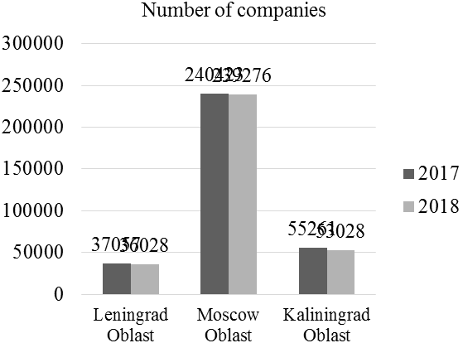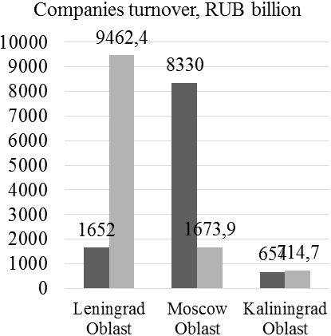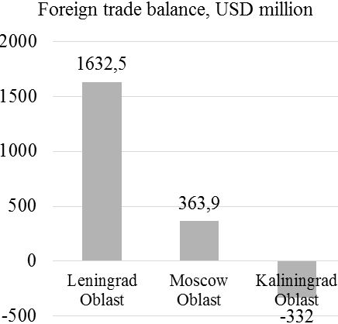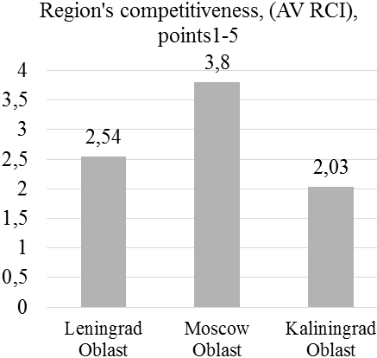

Figure 4. The results of monitoring of foreign economic activities and commodity markets (in dynamics) in top-3 multicultural regions of Russia

in 2017-2018.

Source: compiled by the authors based on Federal State Statistics Service (2019) and the Forum of Strategists – 2018: stakeholders of the future (2019).

According to Figure 4, foreign trade balance in Leningrad Oblast (USD 1,632.5 million) and in Moscow Oblast (USD 363.9 million) is positive. Growth rate of the number of companies in Leningrad Oblast constitutes 0.97 (36,028/37,057), in Moscow Oblast – 1.00 (239,276/240,423). Growth rate of companies’ turnover in Leningrad Oblast constitutes 5.73 (9,462/1,652), in Moscow Oblast – 0.20 (1,673.9/8,330). Both regions should stimulate innovations for increasing the competitiveness, which, as of 2018, constituted 2.54 points in Leningrad Oblast and 3.8 points in Moscow Oblast.

In Kaliningrad Oblast, foreign trade balance is negative – USD -332 million. Growth rate of the number of companies in Kaliningrad Oblast constitutes 0.96 (53,028/55,261), and growth rate of companies’ turnover – 13.09 (714.7/654). Import substitution is recommended in this region. The implementation of the offered measure is supported by high competitiveness of Kaliningrad Oblast, which, as of 2018, constituted 2.03 points.

The results of the performed approbation of both developed algorithms showed that monitoring of the number and structure of population (in dynamics) and the labor market and monitoring of foreign economic activities and commodity markets (in dynamics) in Russia’s multicultural regions do not require special collection of statistical data; the existing data of the official statistics and simple analysis suffice.

At the same time, the framework character of the measures of state management of economy, outlined in both algorithms, should be noted. Practical implementation of these measures envisages foundation on the accumulated experience of stimulation and restraint of migration and foreign economic activities in each multicultural region and determination – in view of this experience – of the most preferable tools of management, which should differ depending on the context.

**4 Conclusion**

It is possible to conclude that modern multicultural regions require flexible state management of their economy in two directions: migration flows and foreign economic activities. The problem of supporting high flexibility of state management of economy of multicultural regions consists in underdevelopment of the scientific and methodological provision of this management depending on the context, current needs, and region’s needs.

A perspective solution of this problem is usage of the developed and presented algorithms of flexible state management of migration flows and foreign economic activities in a multicultural region. The compiled algorithms reflect the conditions of stimulation or restraint of certain economic activities in a multicultural region and offer the framework measures of state management.

The advantage of the developed algorithms is that their practical application does not require collection of additional statistical data; simple analysis of the available data suffices. The performed approbation of the developed algorithms by the example of top3 multicultural regions of Russia showed simplicity of their practical application. For Leningrad and Moscow Oblasts, it is recommended to stimulate innovative development of economy for increasing its competitiveness for further increase of import. Import substitution is recommended in Kaliningrad Oblast. Stimulation of population’s employment is recommended in all regions. Additional support for migrants is recommended for Moscow and Kaliningrad Oblast.

**Acknowledgments**

The chapter was prepared with financial support of the Russian Fund for Fundamental Research. Grant of the RFFR 19-410-220004\19 (2019–2020).

**References**

1. [Bezrukova, T.L.](https://proxylibrary.hse.ru:2073/authid/detail.uri?origin=resultslist&authorId=55928786800&zone=), [Popova, E.V.](https://proxylibrary.hse.ru:2073/authid/detail.uri?origin=resultslist&authorId=56711639900&zone=), [Korda, N.I.](https://proxylibrary.hse.ru:2073/authid/detail.uri?origin=resultslist&authorId=57195717503&zone=), [Kuznetsova, T.E.](https://proxylibrary.hse.ru:2073/authid/detail.uri?origin=resultslist&authorId=55861954300&zone=), [Bezrukov, B.A.](https://proxylibrary.hse.ru:2073/authid/detail.uri?origin=resultslist&authorId=55928925300&zone=) (2017). I[nstitutional traps of innovative and investment activities as an obstacle on the path to the well-balanced development of regions](https://proxylibrary.hse.ru:2073/record/display.uri?eid=2-s2.0-85029596912&origin=resultslist&sort=plf-f&src=s&st1=balanced+development+region&st2=&sid=7b05dfc5fd43670f6686a9d446301d12&sot=b&sdt=b&sl=34&s=TITLE%28balanced+development+region%29&relpos=1&citeCnt=0&searchTerm=). [Contributions to Economics](https://proxylibrary.hse.ru:2073/sourceid/91803?origin=resultslist), (9783319606958), p. 235-240.
2. [Rocha, R.](https://proxylibrary.hse.ru:2073/authid/detail.uri?origin=resultslist&authorId=35107885700&zone=), [Abreu, M.](https://proxylibrary.hse.ru:2073/authid/detail.uri?origin=resultslist&authorId=24390508600&zone=) (2018). [Emerging strategies and flexible forms of governance: The dynamics of role exchange in local value chains](https://proxylibrary.hse.ru:2073/record/display.uri?eid=2-s2.0-85048067723&origin=resultslist&sort=plf-f&src=s&st1=flexible+governance&st2=&sid=6751029ccbbb3ee2bc376dcc6e538a59&sot=b&sdt=b&sl=26&s=TITLE%28flexible+governance%29&relpos=4&citeCnt=0&searchTerm=). [Competition and Change](https://proxylibrary.hse.ru:2073/sourceid/21100255381?origin=resultslist), 22(4), p. 363-382.
3. [Frolov, D.P.](http://proxylibrary.hse.ru:2178/DaisyOneClickSearch.do?product=WOS&search_mode=DaisyOneClickSearch&colName=WOS&SID=D4wcR7RtBoC5epnnrv3&author_name=Frolov,%20Daniil%20P.&dais_id=2950502&excludeEventConfig=ExcludeIfFromFullRecPage), [Popkova, E.G.](http://proxylibrary.hse.ru:2178/DaisyOneClickSearch.do?product=WOS&search_mode=DaisyOneClickSearch&colName=WOS&SID=D4wcR7RtBoC5epnnrv3&author_name=Popkova,%20Elena%20G.&dais_id=1171917&excludeEventConfig=ExcludeIfFromFullRecPage), [Strekalova, A.S.](http://proxylibrary.hse.ru:2178/DaisyOneClickSearch.do?product=WOS&search_mode=DaisyOneClickSearch&colName=WOS&SID=D4wcR7RtBoC5epnnrv3&author_name=Strekalova,%20Anastasia%20S.&dais_id=9278046&excludeEventConfig=ExcludeIfFromFullRecPage) (2017). [Strategic Planning of Regional Ecological Development: Adaptation of Elinor Ostrom's Principles in Russia](http://proxylibrary.hse.ru:2178/full_record.do?product=WOS&search_mode=DaisyOneClickSearch&qid=3&SID=D4wcR7RtBoC5epnnrv3&page=1&doc=17). Russia and the European Union: development and perspectives. Book series: Contributions to Economics, p. 39-45.
4. [Hilmer Pedersen, K.](https://proxylibrary.hse.ru:2073/authid/detail.uri?origin=resultslist&authorId=57203219732&zone=), [Johannsen, L.](https://proxylibrary.hse.ru:2073/authid/detail.uri?origin=resultslist&authorId=7004068970&zone=) (2018). [New Public Governance in the Baltic States: Flexible Administration and Rule Bending](https://proxylibrary.hse.ru:2073/record/display.uri?eid=2-s2.0-85050991356&origin=resultslist&sort=plf-f&src=s&st1=flexible+governance&st2=&sid=6751029ccbbb3ee2bc376dcc6e538a59&sot=b&sdt=b&sl=26&s=TITLE%28flexible+governance%29&relpos=5&citeCnt=0&searchTerm=). [Public Performance and Management Review](https://proxylibrary.hse.ru:2073/sourceid/5800169457?origin=resultslist), 41(3), p. 648-667.
5. [Hu, J.](https://proxylibrary.hse.ru:2073/authid/detail.uri?origin=resultslist&authorId=55265125700&zone=), [Wu, T.](https://proxylibrary.hse.ru:2073/authid/detail.uri?origin=resultslist&authorId=57199753041&zone=), [Fei, J.](https://proxylibrary.hse.ru:2073/authid/detail.uri?origin=resultslist&authorId=57205744069&zone=) (2018). [Flexible governance in China](https://proxylibrary.hse.ru:2073/record/display.uri?eid=2-s2.0-85061395706&origin=resultslist&sort=plf-f&src=s&st1=flexible+governance&st2=&sid=6751029ccbbb3ee2bc376dcc6e538a59&sot=b&sdt=b&sl=26&s=TITLE%28flexible+governance%29&relpos=6&citeCnt=1&searchTerm=). [Asian Survey](https://proxylibrary.hse.ru:2073/sourceid/15713?origin=resultslist), 58(4), p. 679-703.
6. [Oliveira, E.](https://proxylibrary.hse.ru:2073/authid/detail.uri?origin=resultslist&authorId=56100165200&zone=) (2017). [Editorial for virtual special issue: The emergence of new forms of flexible governance arrangements in and for urban regions: An European perspective](https://proxylibrary.hse.ru:2073/record/display.uri?eid=2-s2.0-85034601231&origin=resultslist&sort=plf-f&src=s&st1=flexible+governance+region&st2=&sid=a0e53b82fdf160de2a00400802d592ba&sot=b&sdt=b&sl=33&s=TITLE%28flexible+governance+region%29&relpos=0&citeCnt=1&searchTerm=). [Regional Studies, Regional Science](https://proxylibrary.hse.ru:2073/sourceid/21100463803?origin=resultslist), 4(1), p. 1-6.
7. Popkova, E.G. (2013). [Marketing strategy to overcome the "underdevelopment whirlpool" of the Volgograd region](http://proxylibrary.hse.ru:2178/full_record.do?product=WOS&search_mode=DaisyOneClickSearch&qid=3&SID=D4wcR7RtBoC5epnnrv3&page=1&doc=42), Proceedings of the 11th Eurasia business and economics society conference (EBES), p. 52-61.
8. [Popkova, E.G.](https://proxylibrary.hse.ru:2073/authid/detail.uri?origin=resultslist&authorId=55671568200&zone=), [Popova, E.A.](https://proxylibrary.hse.ru:2073/authid/detail.uri?origin=resultslist&authorId=57193336965&zone=), [Denisova, I.P.](https://proxylibrary.hse.ru:2073/authid/detail.uri?origin=resultslist&authorId=28367576500&zone=), [Porollo, E.V.](https://proxylibrary.hse.ru:2073/authid/detail.uri?origin=resultslist&authorId=57193329992&zone=) (2017). [New approaches to modernization of spatial and sectorial development of Russian and Greek regional economy](https://proxylibrary.hse.ru:2073/record/display.uri?eid=2-s2.0-85013057549&origin=resultslist&sort=plf-f&src=s&st1=Popkova+E.G.&st2=&sid=d228744c663fd02e49393ab46b8e284f&sot=b&sdt=b&sl=25&s=AUTHOR-NAME%28Popkova+E.G.%29&relpos=48&citeCnt=9&searchTerm=). [European Research Studies Journal.](https://proxylibrary.hse.ru:2073/sourceid/21100216333?origin=resultslist) 20(1), p. 129-136.
9. Sergi, B.S., Bagatelas, W.T., Kubicova, J. (2012).  Industries and Markets in Central and Eastern Europe. Ashgate Publishing.
10. Sergi, B.S., Popkova, E.G., Bogoviz, A.V., Ragulina J.V. (2019). Entrepreneurship and economic growth: the experience of developed and developing countries. Entrepreneurship and development in the 21st century. Emerald publishing limited, 3-32.
11. Shakhovskaya, L., Petrenko, E., Dzhindzholia, A., Timonina, V. (2018). Market peculiarities of natural gas: Case of the Pacific Region. Entrepreneurship and Sustainability Issues, 5(3), 555-564. DOI: <https://jssidoi.org/jesi/article/167>.
12. Simonova, E.V., Lyapina, I.R., Kovanova, E.S., Sibirskaya, E.V. (2017). Characteristics of interaction between small innovational and large business for the purpose of increase of their competitiveness. Contributions to Economics. (9783319552569), с. 407-413. DOI: 10.1007/978-3-319-55257-6_53
13. Vanchukhina, L.I., Leybert, T.B., Rudneva, Y.R., Rogacheva, A.M., Khalikova, E.A. (2019). Industry 4.0 and Closed-Loop Economy in the Context of Solving the Global Problems of Modern Times. Industry 4.0: Industrial Revolution of the 21st Century. Springer International Publishing AG, part of Springer Nature, 169, p. 31-53.
14. Federal State Statistics Service (2019). Regions of Russia: socio-economic indicators – 2019. URL: <http://www.gks.ru/wps/wcm/connect/rosstat_main/rosstat/ru/statistics/publications/catalog/doc_1138623506156> (data accessed: 20.06.2019).
15. Forum of Strategists – 2018: stakeholders of the future (2019). The best practices of stimulation of development and increase of competitiveness of regions. The index of competitiveness of Russia’s regions – AV RCI-2018 beta. URL: http://lc-av.ru/wp-content/uploads/2018/10/LC-AV.RCI-2018-181021.pdf (data accessed: 20.06.2019).

1. Elena V. Kletskova

   Altai State University, Barnaul, Russia

   e-mail: [kletskova_elena@mail.ru](mailto:kletskova_elena@mail.ru); ORCID: 0000-0002-4694-1936

   Olga V. Titova

   Altai State University, Barnaul, Russia

   e-mail: [otitova82@icloud.com](mailto:otitova82@icloud.com); ORCID: 0000-0002-7669-709Х

   Viktoria V. Vorobyeva

   Altai State University, Barnaul, Russia

   e-mail: [vvvtoria@mail.ru](mailto:vvvtoria@mail.ru); 0000-0003-2999-1453